Eudey, Econ 302, January 2019
Trends and Cycles in GDP: Reference Chapter 3
Reading
Things you can skip from this chapter:
Edition 5
- The sections on “Nominal Variables” and “Seasonal Adjustment”
Edition 6
- The sections on “The Price Level and Inflation” and “Seasonal Adjustment”

Trend GDP
One of the basic pieces of data that we use in macro is the chain-weighted measure of real GDP. It is not a precise measure of the amount produced in a given time period, but when we talk about real GDP everyone is talking about the same data measured in the same way and we are familiar with its strengths and weaknesses as a measure of aggregate activity (see Chapter 2, Williamson, if you either need or want a review of how real chain-weighted GDP is measured, but I won’t either emphasize, or test you on, that measurement in this course.)
The following image is a plot of the trend in log GDP, where the trend moves over time—steep in some periods (like the rapid labor growth period of the late 1960s and the New Economy high-tech boom of the late 1990s) and flatter in others (like during the monetary recession of the early 1980s and during the Great Recession period of 2008-2012). This is just one way to show the trend in the macro-economic data—other statistical methods can be used but this one is fairly popular among macro-economists and is the one preferred by Williamson in the textbook associated with this course. Movements in the trend are associated with long-term changes in the economic environment that fundamentally affect market equilibrium for long periods of time. Models of long-term economic growth are models that focus on explaining the trend movements in economic data.

Business Cycles
Business cycles are deviations from trend—they are the difference between the actual data and the estimated trend. Not all economists prefer the same statistical methods for determining the trend, and so even if we start with the same raw data different economists can get different estimates for the size of the business cycle. But in spite of those differences, we all agree about when there is a boom and when there is a recession. A recession statistically is a period below trend (deviation from trend is a negative number) and a boom is a period above trend (deviation from trend is a positive number). This statistical way of determining recessions and booms isn’t the simple “two consecutive quarters of declining GDP” method you likely learned in your intro macro course, but it turns out that it hasn’t really mattered what method you use—if there’s a recession we see it in the data.
In the chart below we see that both the monetary recession of the early 1980s and the Great Recession of 2008-2012 had cyclical business cycle components as well as an impact on the long-term trend that we saw in the previous figure

Chapter 3 has a nice graphic that demonstrates what is going on here: The first chart of the Moving Average GDP trend is a real-world plot of the trend in the stylized example below; the second chart of the Deviations from the Moving Average Trend is a plot of the difference between the actual data and the trend data. A trough is when the cycle is most negative, a peak is when the cycle hits a high-point; the amplitude measures how big the cycle is (either positive or negative)
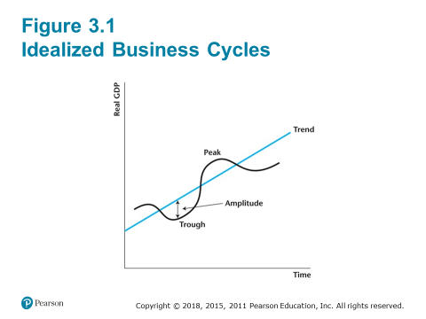
The method of detrending doesn’t have a big impact on what we do, but it is important that we remove trends from data before we try to talk about the business cycle—we want our business cycle analysis to line up with cyclical data (using the Scientific Method) and so we need to know what those data are.
Stylized Facts of the Business Cycle
If you need a refresher on what major macro-economic aggregates are or how they are measured, you can read Chapters 1 and 2, but we won’t spend time on those measurements in this course.
The “stylized facts” of the business cycle are the data we try to explain with business cycle theory. If we can do a precise job of understanding historical data, it improves the changes that we’ll do a good job of forecasting future movements in those data. That is useful if you are in business, but understanding the working of the economy is also necessary to guide policy and regulation.

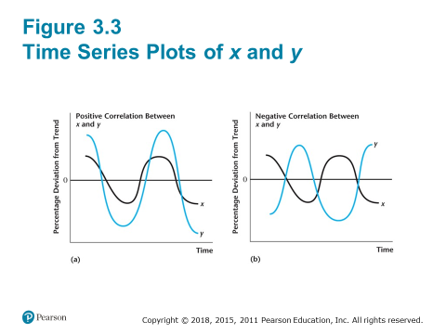

Variables that are positively correlated rise together over the business cycle and fall together over the business cycle—at least on average. If they are very highly positively correlated, then it means they tend to do this all the time. If they are very highly negatively correlated, then it means that they tend to move in the exact opposite direction from each other over the business cycle
Here are some examples that we’ll refer to throughout the course as the “stylized facts” of the business cycle. They are “stylized” because the data are detrended and not in “raw” data form, and they are “facts” in quotation marks because the correlations are averages observed in history and aren’t necessarily things we expect to see at any one time in either the current or future economy. “Stylized facts” aren’t really “truth”—they are things we’ve observed so far in the data.
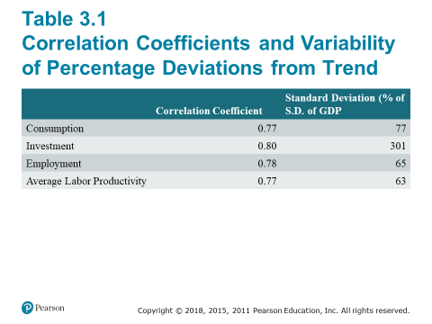
These data in Table 3.1 show the correlations of each economic aggregate with the cyclical component of real GDP. We say that variables that are positively correlated with GDP over the business cycle are “pro-cyclical” and those that are negatively correlated with GDP over the business cycle are “counter-cyclical”
